GeoComply: The Story So Far
WRITTEN FOR AN INTERVIEW EXERCISE. Built from public information about GeoComply and the US market.

The story
In 2011, online gambling (iGaming) in the US was about to return, one state at a time, on one condition. A bet only counted if the person placing it was physically inside a state that allowed it. The internet had no reliable way to know that. An IP address was an estimate, and a VPN could change it in seconds.
Anna Sainsbury and David Briggs started GeoComply in Las Vegas that year to build the missing piece: a location check precise enough that a regulator would accept it. They signed 13 gambling operators and rented a house near Atlantic City to be close to their first big launch.
The company moved from Las Vegas to Vancouver in 2016, but much of what it builds is built far from either city. Today it has offices on three continents, with engineering teams in Ho Chi Minh City and Warsaw as well as Canada.
For the next five years, the business grew state by state. Then, in May 2018, the US Supreme Court struck down the federal ban on sports betting, and every state could decide for itself. In the period that followed, the company reported revenue growth of more than 1,500% and doubled its headcount. Each state that opened brought new customers, because in each one, operators were required by law to verify where their players were.
GeoComply also became part of how those decisions get made. It testifies to state lawmakers with its own data on residents trying to bet from states where it isn't legal. During the 2023 Super Bowl weekend, people in Missouri, which had no legal betting then, were blocked 250,000 times. Missouri opened online betting in December 2025.
Fences attract climbers. Spoofed GPS apps, remote desktops, emulators, phones wiped to look brand new. The data collected to prove where someone was also showed who was trying to hide it. Fraud prevention grew out of compliance, from the same checks.
In 2019, operators asked for help with the step before the bet: confirming who a new player is, and that they are old enough. That became IDComply.
The same tools work outside gaming. GeoComply serves media, fintech and regulated gaming. The technology built to catch out-of-state bettors now targets scammers as well, including the "pig butchering" operations described in the 2024 white paper on The Table.
Today the company describes itself as a digital identity company: where someone is, what device they are on, and who they are, checked together.
Every check has a cost on the other side. A check that blocks a real person costs the operator a customer, as surely as fraud costs them money. So does an ID photo step slow enough that people give up and leave. The work is to stop the wrong people while the right ones barely notice.
How much a check costs depends on who is being asked. In gambling, people expect to be asked where they are. It is part of the deal. In a coffee app or a social network, the same question feels intrusive.
Anna has described one use as a lock on your fridge: a way for people who want a break from gambling to make sure they get one.
Here is what has changed. Most of the US states that were going to open online sports betting quickly have done so. In 2019, six jurisdictions launched. In 2025, one did. California, the largest state, still has no legal sports betting. Growth that once came from new states opening now has to come from new industries: streaming, payments, prediction markets, health.
Those industries differ in one important way. A sportsbook in New Jersey must check where its players are, because the law says so. A streaming service or a bank usually doesn't have to. It chooses to, if the check is worth the cost and the friction it adds for its own customers.
That changes what the product is. A sportsbook has to obey a failed check: no location, no bet. Customers in other industries often take the same result as one signal among many, and make their own decision.
The problem is different in each industry, too. A streaming service enforces licences that stop at a border, against viewers on VPNs. A ticket seller fights bots, which can be caught without asking anyone for their location. A bank screening for sanctions often relies on an IP address, which is easy to fake. A product built for one sportsbook usually works for the rest, but GeoComply's state of the art products rarely carries over from one industry to the next unchanged.
And "required" can change. Prediction markets began by arguing that their sports contracts were not gambling. Since 2025, regulators in at least seven states have ordered them to stop, and several of those cases are in court. An industry can move from choosing to being required quickly.
For most of its history, GeoComply sold to customers who were required to buy. In new industries, it has to be chosen.
That is where the story is now.

The runway
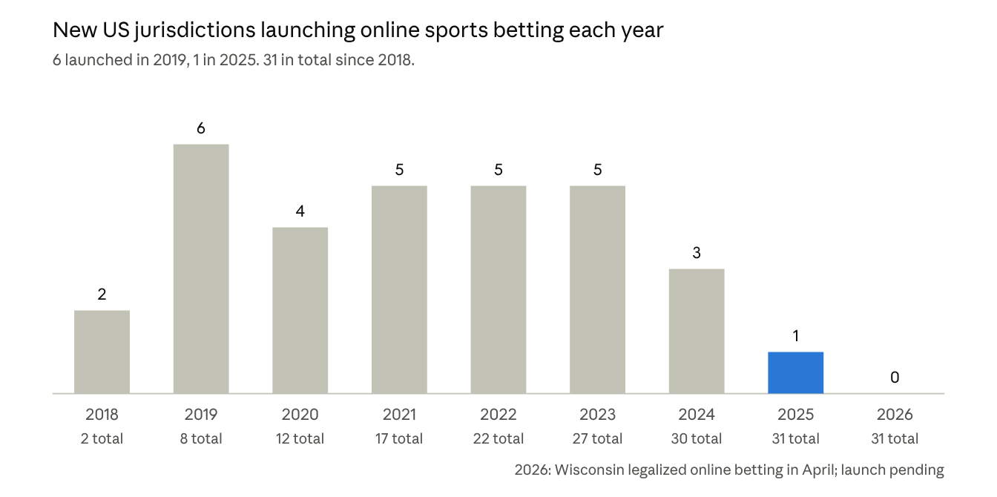
LegalSportsBetting.com launch timeline, checked against RG.org and CBS Sports · online launches 2018 to October 2026
Here’s what has changed. The states that were going to open online betting quickly mostly have. In 2019, six jurisdictions launched; in 2025, one did. The core business is mature: large, secure, and growing more slowly than it once did.
The places where GeoComply is seeing real growth are now in what grew out of it. Fraud prevention started as a second use of the same location checks. Identity started when operators asked for help with the step before the bet.
Today they’re becoming one thing: knowing where someone is, what device they’re on, and who they are, together. That’s what GeoComply means by a digital identity company, and it’s why the company has moved into fintech, streaming, health and prediction markets.
Those industries don’t have to buy. They choose to, when the check is worth it, and a lot of them have. That makes the work harder and more interesting. Some deals move fast; some stall on questions nobody had to answer before.
The next chapter is being written now, partly by whoever joins next.

Milestones
Year | What happened
Today | Describes its products as verifying a user's true digital identity: location, device and identity together | GeoComply
2025 | Kip Levin, former president of FanDuel, becomes CEO. Anna Sainsbury becomes executive chair; David Briggs moves to focus on product and innovation | SBC Americas
2024 | Publishes research on detecting "pig butchering" scam compounds | On this table
2023 | Company acquires “OneComply,”
2022 | Investment from Blackstone Growth values the company at US$1 billion | BIV
2022 | Standing with Ukraine. GeoComply’s second largest office based in Karkiev is shut down as Russia invades Ukraine. GeoComply helps employees and some of their families leave the country and settle in Poland and Canada | The Logic
2019 | Launches IDComply for age and identity checks, at customers' request | GeoComply
2018 | US Supreme Court strikes down the federal sports betting ban on May 14 | RG.org
2016 | Moves from Las Vegas to Vancouver for access to talent | Maclean's
2013 | Location check launches, two years after founding | Women of Influence
2011 | Founded in Las Vegas by Anna Sainsbury and David Briggs | Maclean's

Sources
- The Power List: Anna Sainsbury, Maclean's
- How Anna Sainsbury built GeoComply, Women of Influence
- GeoComply co-founder returns as CEO, Business in Vancouver, January 2022
- GeoComply announces IDComply, GeoComply, October 2019
- IDComply licensed in New Jersey, GeoComply
- Global offices, GeoComply
- David Briggs biography, Sutton Trust
- Written testimony to the Vermont House, GeoComply, February 2023
- More than 100 million geolocation checks for the Super Bowl, CDC Gaming
- States with legal sports betting: launch timeline, LegalSportsBetting.com, 2026
- Sports betting launch timeline 2018 to 2026, RG.org
- Where all 50 states stand on sports betting, CBS Sports
- Arizona regulator sends cease-and-desist, The Event Horizon
- Connecticut sues over unlicensed sports betting, WFSB, August 2026

